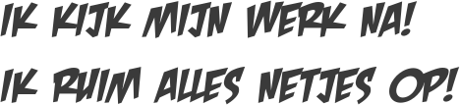https://fontmeme.com/temporary/d06ac09b44dad052cc7c7377fe0167eb.png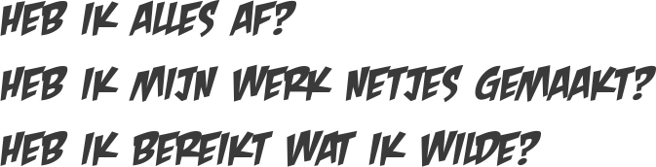https://fontmeme.com/temporary/a4500fddc0c125aa5197472739460eca.png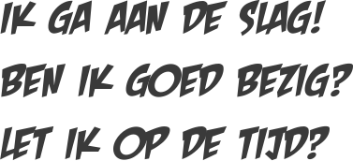https://fontmeme.com/temporary/eb72943624ac303cc66e5fc1fda65bf1.png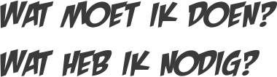https://fontmeme.com/temporary/f34fcacc58c9e41cce2f99ddbc26ab92.png